**CHAPTER ONE**

**INTRODUCTION**

1. **Background of The Study**

Management of prisons in Nigeria has long been a neglected area which has recently been incorporated in the e-governance program of Government of Nigeria. Currently a rudimentary process of storing all the prisoner data in manual files and registers is in place. The Prison Management System project will integrate all the prisoner data into a single integrated system which will in turn result all the information being present in a digital format. ICT in prisons was initiated in the year 2002 at Delhi Prisons, Tihar. (Aderind & Stepheny, 2018)

The Tihar Prisons Complex in New Delhi is the biggest prison complex in Asia comprising of 9 prisons and one District Jail at Rohini with a total strength of more than 11,000 prisoners against a normal sanctioned capacity of 6250 prisoners. In a year about 70,000 - 80,000 inmates remain lodged in these prisons for different duration and crimes committed by them. (Hamlet, 2017)

This prison population has about 80% under trials and includes about 480 women inmates. About 400 inmates are foreigners from different parts of the world. Many high security criminals also live here. There has been a substantial increase in number of prison inmates coming to Tihar because of a phenomenal increase in the crime scene at Delhi that has resulted in the increase of the ICT needs and its management at the Tihar Jail Complex. (Rosenberg, 2016)

Nearly 1700-1800 visitors meet their relative inmates’ every day. There was manual system of booking (meetings) in each jail for its respective inmates. Centralized visitor record was not available. There was lack of exchange of visitors’ information within jails and prison headquarters. No provision for identification / detection / verification of visitors was there.

Managing the prisoner record and monitoring of prisoner / visitor was always difficult since most of the records were normally maintained manually, so the concerned authorities were required to go through all the registers to find out the details and status of the inmate as well as of the visitor.

In order to cope up with the increasing number of prisoners being lodged in, the Tihar Administration required a re-engineering and rationalization of their key business processes and functions of prisoners’ related information and their computerization in order to speed up the processing of information need of courts and various other national agencies. (Alan, 2017).

As the technology evolution is taking place, there arose a need for centralization of prisoner’s data to facilitate information exchange and data sharing to the users of the prison. It shall reduce administrative overheads, speed up responsiveness to users, reduce risks involved in inmate’s custody, eliminated obsolete processes and reap cost-cutting benefits.

1. **Statement of Problem**

Management of prison’s in Nigeria is still at a nascent stage and follows rudimentary processes. Most of the prisons in Nigeria have a collection of manual files and registers to store prisoner/criminal records. This is a very inefficient and cumbersome way of storing records which greatly impedes the flow of critical information as well as makes looking up of information time consuming. Also, different files and registers are required to store the information which is relevant to a single prisoner. This hinders the profiling process of prisoners.

**1.3 Aim and Objectives of the Project**

The main aim of this project is to implement a Prison Management System (PMS) that can enhance the administrative capabilities of the jails in terms of monitoring and security of the prison while improving the efficiency and productivity of the Prisons. The objectives of the project are enunciated below:

1. To ensure proper monitoring of the prisons by the top officials
2. To ensure that the discipline and decorum of the jails is maintained by both the employees and the prisoners
3. To ensure that no impersonation of the prisoners happens by proper validation and authentication of the prisoner’s identity
4. To improve the productivity and efficiency of the prisons so as to facilitate the usage of the available work force for sensitive work while leveraging technology to reduce the mundane workload of the employees
5. To ensure the availability of data in digital form for preservation, analysis and reporting.
6. **Significance of The Project**

The nature of project is such that outcome of project could be quantitatively measured only for few parameters such as:

1. Automatic detection of duplication
2. Immediate generation of report on categorization of prisoners on basis of their cases,

period of confinement etc.

**1.5 Scope of the Project**

The basic purpose of this project is to develop an online system for prison management. The system developed covers prisoner’s information such as picture, conviction, offence, visitors, address, jail term record etc.

**1.6 Limitations of the Project**

Generally, a study of this nature would have some constraints such as time, money and data collection method. I wish to say that data collection method used has the limitation of rigidity (people finding it difficult to respond to questions) thereby restricting the information obtained.

Also lack of finance is another obstacle that hindered a wider consultations and research on the project. Some materials may have some cost implications which may be above the budgeted money for the research work.

* 1. **Definition of Terms**

**Data**- This can be defined as facts about the organization and its business transaction.

**Information*-***This can be defined as data that has been transformed and organized by

processing and purposeful intelligence.

**Information system-** This is an arrangement of people, data, processes and interface that

interact to support and improve day to day operation in a business as well as support the

problem solving and decision-making needs for management and users.

**Management:** It is the co-ordination of all the resources of an organization through the

process of planning, organization, directing and controlling in order to attain organizational

objectives.

**CHAPTER TWO**

**LITERATURE REVIEW**

1. **Database Management System**

The introduction of computer into information technology has massively improved the information need of organization; the success of this machine is dependent on the knowledge base. A database is an organized collection of data. The data is typically organized to model relevant aspects of reality, in a way that supports processes requiring this information.

Database management systems (DBMS) are specially designed applications that interact with the user, other applications, and the database itself to capture and analyze data. A general-purpose database management system (DBMS) is a software system designed to allow the definition, creation, querying, update, and administration of databases. A database is not generally portable across different DBMS, but different DBMS can inter-operate by using standards such as SQL and ODBC or JDBC to allow a single. Database management system is typical information processing system or organizational information system on people’s information. World Net describes an information system (I.S) as “a system consisting of the network of all communication channels used within an organization, and includes software and hardware”. It may also be defined as “a system that collects and processes data (information) and provides it to mangers at all levels that use it for decision making, planning, program implementation and control. (Ullman & Wisdom, 2017)

The aim of information system in immigration is improving the quality and accuracy of information provided to all involved as well as assisting management in compiling and reporting information.

Computerization is a social process for providing access to and support for computer equipment to be used in activities such as teaching, accounting, writing, designing, circuits, file processing etc. computerization entails social choices about the levels of appropriate investment and control over equipment and expertise, as well as choices of equipment. (Ullman & Wisdom, 2017)

Database management systems (DBMS) have become a standard tool for shielding the computer user from details of secondary storage management. They are designed to improve the productivity of application programmers and to facilitate data access by computer-naive end users. There have been several database models. Whichever conceptual model or database management system is adopted, the use of a central database management system has a number of advantages and some costs compared to the commonly employed special purpose data files. A data file consists of a set of records arranged and defined for a single application system. Relational information between items in a record or between records is not explicitly described or available to other application systems. For example, a file of project activity durations and scheduled times might be assembled and manipulated by a project scheduling system. This data file would not necessarily be available to the accounting system or to corporate planners. (Torrington, 2018)

**Centralized DBM has several advantages over such stand-alone systems:**

1. **Reduced redundancy** good planning can allow duplicate or similar data stored indifferent files for different applications to be combined and stored only once.
2. **Improved availability** information may be made available to any application program through the use of the DBM
3. **Reduced inconsistency** if the same data is stored in more than one place, then updating in one place and not everywhere can lead to inconsistencies in the database.
4. **Enforced data security** authorization to use information can be centralized.

For the purpose of project management, the issue of improved availability is particularly important. Most application programs create and own particular data files in the sense that information is difficult to obtain directly for other applications. Common problems in attempting to transfer data between such special purpose files are missing data items, unusable formats, and unknown formats. (Srinivas, 2018)

1. **Management Information System (MIS)**

The concept of the MIS has evolved over a period of time comprising many different facets of the organizational function. MIS is a necessity of all the organizations. The initial concept of MIS was to process data from the organization and presents it in the form of reports at regular intervals. The system was largely capable of handling the data from collection to processing. It was more impersonal, requiring each individual to pick and choose the processed data and use it for his requirements. This concept was further modified when a distinction was made between data and information. The information is a product of an analysis of data. This concept is similar to a raw material and the finished product. What are needed are information and not a mass of data. However, the data can be analyzed in a number of ways, producing different shades and specifications of the information as a product. It was, therefore, demanded that the system concept be an individual- oriented, as each individual may have a different orientation towards the information. This concept was further modified, that the system should present information in such a form and format that it creates an impact on its user, provoking a decision or an investigation. It was later realized then even though such an impact was a welcome modification, some sort of selective approach was necessary in the analysis and reporting. Hence, the concept of exception reporting was imbibed in MIS. The norm for an exception was necessary to evolve in the organization. The concept remained valid till and to the extent that the norm for an exception remained true and effective. Since the environment turns competitive and is ever changing, fixation of the norm for an exception becomes futile exercise at least for the people in the higher echelons of the organization. The concept was then evolved that the system should be capable of handling a need based exception reporting. This need maybe either of an individual or a group of people. This called for keeping all data together in such a form that it can be accessed by anybody and can be processed to suit his needs. The concept is that the data is one but it can be viewed by different individuals in different ways. This gave rise to the concept of DATABASE, and the MIS based on the DATABASE proved much more effective. (Srinivas, 2018)

Over a period of time, when these conceptual developments were taking place, the concept of the end user computing using multiple databases emerged. This concept brought a fundamental charge in MIS. The change was decentralization of the system and the user of the information becoming independent of computer professionals. When this becomes a reality, the concept of MIS changed to a decision making system. The job in a computer department is to manage the information resource and leave the task of information processing to the user. (Srinivas, 2018)

The concept of MIS in today’s world is a system which handles the databases, databases, provides com-putting facilities to the end user and gives a variety of decision making tools to the user of the system. (Srinivas, 2018)

The concept of MIS gives high regard to the individual and his ability to use information. An MIS gives information through data analysis. While analyzing the data, it relies on many academic disciplines. These include the theories, principles and concepts from the Management Science, Psychology and Human Behavior, making the mis more effective and useful. These academic disciplines are used in designing the MIS, evolving the decision support tools for modeling and decision – making. (Srinivas, 2018)

The foundation of MIS is the principles of management and if its practices. MIS uses the concept of management Information System can be evolved for a specific objective if it is evolved after systematic planning and design. It calls for an analysis of a business, management views and policies, organization culture and the culture and the management style. The information should be generated in this setting and must be useful in managing the business. This is possible only when it in conceptualized as system with an appropriate design. The MIS, therefore, relies heavily on the systems theory offers solutions to handle the complex situations of the input and output flows. It uses theories of communication which helps to evolve a system design capable of handling data inputs, process, and outputs with the least possible noise or distortion in transmitting the information form a source to a destination. It uses the principles of system Design, Viz., an ability of continuous adjustment or correction in the system in line with the environmental change in which the MIS operates. Such a design help to keep the MIS tuned with the business managements needs of the organization. (Srinivas, 2018)

1. **Review of Prison Management System**

Automating and streamlining the process of prisoner / visitor movement at Prisons. Followings are the accomplishment in this area of prison management:

**1) Establishment of LAN**: Establishment of LAN connecting all prisons situated in a big wide spread complex using 5,500 meters of Optical Fiber Cable (12 and 6 core) operated with one Layer - 3 switch supported by 16 Layer - 2 switches in the entire jail complex.

The network has 185 IOs and can be expanded to 300 nodes without any additions / modifications / disruptions to the existing infrastructure. Surveys were got conducted and laying of OFC was found to be the best suitable option;

**2) Development and Implementation of PMS**: Prison Management System (PMS) comprises of 12 primary functional modules. More than 65 reports of various types have been developed under Client / Server architecture. It has been developed, tested and implemented. This PMS is having following major features:

1. Based on Client-Server Architecture and supporting latest GUI features;
2. Centralized Database for supporting powerful & fast retrieval of data;
3. Monitors physical location of inmate, their movements within and outside the jail complex, punishments, medical history of the inmate at the time of his / her arrival at the jail, cases filed against him, court hearings among other attributes.
4. **Human Resource Management (HRM)**

The term ‘Human Resource Management’ has been the subject of considerable debate, and its underlying philosophy and character are highly controversial. Much of this controversy stems from the absence of a precise formulation and agreement on its significance and definition as cited by (Bratton & Gold, 2019).

Obviously, definition of the subject matter is needed for analysis and understanding of HRM theory and practice.

HRM has a variety of definitions but there is general agreement that it has a closer fit with business strategy than previous models, specifically personnel management. In all the debates about the meaning, significance and practice of HRM, nothing seems more certain than the link between HRM and performance (HRM Guide October 2018).

Below are some of the definitions of HRM, although it can be argued that these will only be ones of several possible definitions.

HRM is defined as the part of the organization that is concerned with the people dimension, and it is normally a staff or support function in the organization. HRM role is the provision of assistance in HRM issues to line employees, or those directly involved in producing the organization’s goods and services. Acquiring people’s services, developing their skills, motivating them to high levels of performance, and ensuring their continuing maintenance and commitment to the organization are essential to achieving organizational goals. This is much the case regardless of the type of organization, government, business, education, health, recreation, or social action. The authors proposed an HRM specific approach as consisting of four functions- staffing, training and development, motivation, and maintenance. (Cenzo & Robbins, 2017)

In addition, HRM is defined as the strategic approach to managing employment relations which emphasizes that leveraging people’s capabilities is critical to achieving sustainable competitive advantage. This is achieved through a distinctive set of integrated employment policies, programs and practices. The authors presented HRM functions as planning, recruitment and selection, appraisal and performance management, reward management, development, employee relations, health and safety, and union-management relations. (Bratton & Gold, 2018)

Moreover, HRM aims at recruiting capable, flexible and committed people, managing and rewarding their performance and developing key competencies. (Alan Price, 2020).

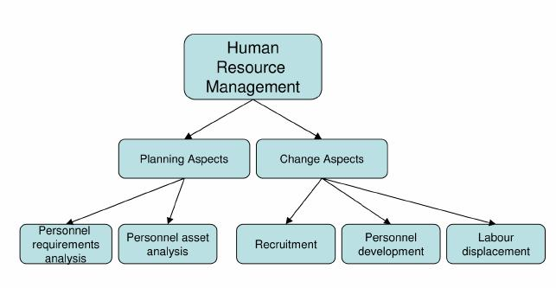They see HRM as a strategic and target oriented composition, regulation and development of all areas that affect human resources in a company. Efficient and effective management of these resources to a large extend, affects human resource behavior, and consequently the performance of the organization as a whole. Moreover, the authors identified HRM with the field it covers. These include planning aspects- personnel requirements analysis and personnel asset analysis, and change aspects- recruitment, personnel development and labor displacement. (Abecker et al, 2017)

**Figure2.1: Fields of HRM (Source: Abecker et al., 2018)**

According to (Torrington et al., 2019) HRM is fundamental to all management activity and has evolved from a number of different strands of thought. It is best described as a loose philosophy of people management rather than a focused methodology. Thus, distinction has been made between HRM as body of management activities on one hand (generically described as personnel management) and then on the other as a particular approach to execute those activities (carrying out people-oriented organizational activities than traditional personnel management). An organization gains competitive advantage by using its employees effectively, drawing on their expertise and ingenuity to meet clearly defined objectives.

(Torrington et al., 2018) identified the role of the human resource functions with four key objectives.

These four objectives are the corner stone of all HR activities. These include Staffing, Performance, Change-management and Administration. Staffing objective focuses on finding the appropriate pool of human resources needed to ensure full and timely supply of work force. It therefore involves designing organizational structures, identifying working conditions for different groups of employees followed by recruiting, selecting and developing the personnel required to fill the roles. Performance objective aims at ensuring workforce motivation and commitment for effective performance.

**CHAPTER THREE**

**METHODOLOGY AND SYSTEM ANALYSIS**

**3.1 General Analysis of the Existing System**

Management of prison’s in Nigeria is still at a nascent stage and follows rudimentary processes. Most of the prisons in Nigeria such as the Nigerian prison service Enugu, have a collection of manual files and registers to store prisoner/criminal records. This is a very inefficient and cumbersome way of storing records which greatly impedes the flow of critical information as well as makes looking up of information time consuming. Also, different files and registers are required to store the information which is relevant to a single prisoner. This hinders the profiling process of prisoners.

**3.2 Method of Data Collection**

A thorough investigation of the current system was made in order to obtain detailed fact about the application area to be re-designed. Investigation also covered looking at the functional requirement of the present system and finding out whether the requirements and objective of the present system are being achieved. In the investigation proper, several methods of data collection were employed which includes interviewing of office representatives, evaluation/ inspection of forms and direct observation. These methods were adopted to ensure the validity of data collected and relevance of the result after processing the data.

**3.2.1 Interviewing**

In view to investigation, prison management staff was interviewed. This method yields the most profitable result as it is obtained by physical contact; hence a firsthand knowledge of the various processes involved is obtained by speaking to the operator of the system. The essential element of the interview is obtained directly and in a short time than when other methods are employed since the interviewer is with the interviewed. This immediate feedback gives the opportunity to ask ambiguous questions and hence, obtain detailed responses.

**3.2.2 Observation**

The method of data collection enables the researchers to witness a firsthand operation of the old system or manual system. Direct observation is the surest method of learning as a scientist and this method was richly employed.

1. **Limitations of Existing System**

The existing system has the following limitations;

* 1. Inefficient organization of prison information and records.
  2. Information look up is cumbersome and time consuming.
  3. Impedes the flow of critical information.

1. **Proposed System**

Taking in mind the above deficiencies, our project effectively deals with the above problems by providing a single integrated system where all the prison as well as prisoner/criminal information will be stored in a single centralized system having complete prisoner profiles [computer science project material](https://www.myschooltrick.com/2017/03/Download-Complete-Computer-Science-Project-Topics-and-Materials.html). Each prisoner profile would have his/her demographic details, a digital photograph of the prisoner as well as his parole, visitor and number of times the prisoner has been out of prison with appropriate reason attached to it. This effectively scales down the time in which critical information has to be transferred to concerned agencies. Also maintenance of records is all the more easy as well as efficient when compared to the manual system.

1. **Advantages of Proposed System**
2. Efficient organization of prison information and records
3. Information look up is easy
4. Substantially decreases the time in which critical information is passed on
5. **Input Analysis**

This system would have two inputs from a user; Authentication and Prisoner details which would be stored in a Database. This database will contain all the information and necessary data required by the application for its functioning. The various tables in the database includes:

1. Prisoners’ database: This will store all the necessary details pertaining to the prisoner profile e.g. Name, age, address etc.
2. Users Database: This will store all the necessary information about the users of the application e.g. name, and password etc.

**3.7 System Modeling**

System Modeling can be done using several Modeling Language, but in this project work, we are using the Unified Modeling Language (UML).

* + 1. **Use Case Diagram**

Use Cases are services or functions provided by the system to its users and to identify the primary elements and processes that form the system. The primary elements are termed as “actors” and the processes are called “Use cases”. The Use Case diagram shows which actors interact with each use case and the purpose of a Use Case diagram is to provide a graphical view of the functionality provided by the system in terms of actors, goals of actors (represented as Use cases) and dependencies between Use cases.

Fig. 3.1 **Administrator Use Case Diagram**

* + 1. **Activity Diagram**

An activity diagram illustrates the dynamic nature of a system by modeling the flow of control from activity to activity. An activity represents an operation on some class in the system that results in a change in the state of the system. Typically, activity diagrams are used to model workflow or business processes and internal operations. Because an activity diagram is a special kind of state chart diagram, it uses some of the same modeling conventions.

**Figure 3.3: Save Activity Diagram**

Valid

Cancel Editing

Save Editing

Save

Close Database

Open Database

Accept ID

Display Details

Invalid?

Display Error Message

Accept Entries

**Figure 3.4: Edit Details Activity Diagram**

Accept ID

Display Details

Cancel Deletion

Valid

Open Database

Close Database

Proceed with deletion

Delete Record

Invalid

**Figure 3.5: Delete Activity Diagram**

**3.3.3 Class Diagrams**

Class diagrams are visual representations of the static structure and composition of a particular system using the conventions set by the Unified Modeling Language (UML). Out of all the UML diagrams types, it is one of the most used ones. System designers use class diagrams as a way of simplifying how objects in a system interact with each other. Using class diagrams, it is easier to describe all the classes, packages, and interfaces that constitute a system and how these components are interrelated.

1. The top partition contains the name of the class.
2. The middle part contains the class’s attributes.
3. The bottom partition shows the possible operations that are associated with the class.

**Figure 3.9: System Class Diagram**

**3.4 Database Design**

A database is a collection of information that is organized so that it can be easily accessed, managed and updated.

**Table 3.1 Name: Login**

|  |  |  |  |
| --- | --- | --- | --- |
| **FIELD NAME** | **DATA TYPE** | **LENGTH** | **DESCRIPTION** |
| username | Character | 10 | Username |
| password | Character | 15 | Password |

**Primary key:** password

**Table 3.2 Name: Personnel**

|  |  |  |  |
| --- | --- | --- | --- |
| **Field Name** | **Data type** | **Size** | **Description** |
| **PERSONNEL**_ID | Integer | 8 | PERSONNEL ID |
| FIRSTNAME | Character | 25 | PERSONNEL FIRST NAME |
| LASTNAME | Character | 15 | PERSONNEL LASTNAME |
| GENDER | Character | 6 | GENDER |
| DATEOFBIRTH | Date | 10 | DATE OF BIRTH |
| PHONENO | Character | 11 | PHONE NO |
| EMAIL | Character | 12 | EMAIL ADDRESS |
| PHOTO | OLE | 20 | RECENT PHOTOGRAPH |
| USERNAME | Character | 15 | USERNAME |
| PASSWORD | Character | 15 | PASSWORD |
| RANK | OLE | 20 | RANK |
| POST | Character | 15 | PERSONNEL POST |

Primary Key = PERSONNEL**_ID**

**3.3 Table: Prisoner**

|  |  |  |  |
| --- | --- | --- | --- |
| **Field name** | **Data Type** | **Size** | **Description** |
| PRISONER_ID | Integer | 8 | PRISONER NO |
| PRISONERNAME | Character | 30 | PRISONER NAME |
| CRIME | Character | 30 | CRIME |
| SENTENCE | Character | 6 | SENTENCE |
| TIME | Character | 7 | TIME |
| DATE | Date | 6 | DATE |

Primary Key =**PRISONER_ID**

**3.4 Table: Cell Block**

|  |  |  |  |
| --- | --- | --- | --- |
| **Field name** | **Data Type** | **Size** | **Description** |
| CELL_ID | Integer | 8 | CELL ID |
| NAME | Integer | 100 | NAME |
| LOCATION | Character | 5 | LOCATION |
| NO_OF_CELLS | Character | 15 | NUMBER OF CELLS |

Primary Key =**CELL_ID**

**3.5 Output Design**

This declares and show the result obtained from the input specified. The output product by the automated system depends on the input. Below is the output specification.

USERNAME

PASSWORD

Login

Clear

**Figure 3.5.1: Login**

FIRSTNAME:

LASTNAME:

PHONE NO:

MARITAL STATUS:

DATE OF BIRTH

GENDER

ADD PERSONNEL

EMAIL

PHOTO

Browse

SAVE

USERNAME:

PASSWORD

RANK:

CANCEL

**X**

**Figure 3.5.2: Personnel**

CELL NAME

LOCATION

CAPACITY

CELL BLOCK

SAVE

CANCEL

**X**

**Figure 3.5.3: Add Cell Block**

**X**

NAME

SENTENCE

PRISONER

CRIME

SELECT

TIME

DATE

SAVE

CANCEL

**Figure 3.5.4: Add Prisoner**

**3.6 System Requirements**

System requirement is a combination of hardware and software components that makes work to be carried out. The system requirement for this research work is subdivided into Hardware and Software requirements.

**3.6.1 Hardware Requirements**

Hardware is the computer equipment and devices that are involved in the function of a computer system together with the software components. Hardware are the physical components of the computer system assembled together to interact with the software in order to form a composite system.

The minimum hardware requirements are:

1. CPU Core i3 processor
2. 100MB available disks space
3. RAM (1 GB)
4. Keyboard
5. Mouse
6. 14’SVGA Colored Monitor
7. U.P.S 650va (uninterrupted power supply)
8. Hard Disk Drive (HDD) of 60GB
   * 1. **Software Requirement**

The software requirements are:

1. Minimum of Window 7 (Remote standalone system)
   1. **Choice of programming Language**

PHP is a server scripting language, and a powerful tool for making dynamic and interactive Web pages, is a widely-used, free, and efficient alternative to competitors such as Microsoft's ASP. Client computers accessing the PHP scripts require web browser only.

**CHAPTER FOUR**

**SYSTEMS IMPLEMENTATION AND EVALUATION.**

**4.1 System Testing and Evaluation**

System testing consists of individual and group test carried out in order to ascertain if a system meets it requirements. The units test is carried out first to ensure the individual units work well before the integration test is carried out to ensure individual modules are integrated as a group. It is focused to check that after integrating modules, two modules are communicating with each other. Every module effect is tested on the entire program. Evaluation is to access the system to see if it does what it is supposed to do, that it is working well and that the user is happy with it. To check if the system is efficient, easy to use, appropriate, you check the requirement and compare it with the evaluation result. It involves the developers and the users. The intend of system evaluation is to collect information about the project as a whole, the functions of the system and the expected user activities, the system architecture and any other details that are helpful in guiding performance testing to achieve the specific needs of the project. It is an ongoing process throughout the performance test.

**4.2 System Conversion Plan**

This entails the strategies involved in converting the existing system (manual method) to the new system (computerized system) after training the users. It is done after the programs has been developed and confirmed that it is running well and is error free. Due to the suitability of parallel conversion approach, it has been selected to be the conversion method for this project. Parallel method puts the new information system online to run simultaneously with the old one for a given period of time so as to correct all likely errors of the new system and make room for adaptation. After the problems are fully taken care of, then the new system should be slowly phased in, while the old system is slowly phased out.

**4.3 System Installation**

The installation of the new system follows immediately after design. The process should generate specification that will be employed and used to develop an information system that solves the problems defined during the system analysis.

When structuring a system, it is important that the system design techniques and procedures be it hardware or software should be independent. This allows installation to take place using whatever hardware or software which turns out to be the most effective in supporting information structure.

The installation of the system is the stage of system development that determines what the new system will do and how it will do it. It is concerned with the co-ordination of the procedure and effective utilization of the procedure and effective utilization of the equipment provided in order to make sure that the goals are achieved. This brings in confidence of the management in the installation plan and it also ensures uninterrupted operation during the implementation period.

**4.3.1 Database Installation**

Database installation is particular about how the database is been made part of the work and up-running. The installation of MySQL database consists of the following steps:

1. Log into the computer as an administrator and down loaded the free MySQL server community edition and save it on the windows desktop
2. Double click the downloaded file, double click setup.exe and click install
3. Click skip sign-up and configure MySQL
4. Click the standard configuration setting and lunch the MySQL server automatically
5. Create a root password and enable root access from remote machines and enter.

Installation is the necessary steps required for installing the software. The following are steps for the installation of the new system:

1. Insert the CD that contain the software into your CD-ROM drive.
2. Open/explore the CD to get zipped folder named visitor
3. Install XAMPP Software 3.1.2
4. Extract the folder and send a copy to htdocs in php folder
5. Follow the on-screen software installation wizard until you successfully finish the installation
6. Double click on Mozilla Firefox
7. Type localhost\pms

**4.5 SECURITY MEASURES**

Since the scope of the website is public, some of the information such as index page, login page e.t.c are available to anyone who visits the website. But some other information and functionalities are restricted to some and not all who visit the website. The restrictions are carried out by the use of passwords which gives different level of access to users. The highest level of access is held by the admin, followed by the staff with lesser access.

**4.6 Program Sample Outputs**

These describe and give the pictorial representation of the program or software; it shows and gives clear understanding of the design, and displays all the interfaces.

**4.6.1 Homepage**

This is the program homepage.

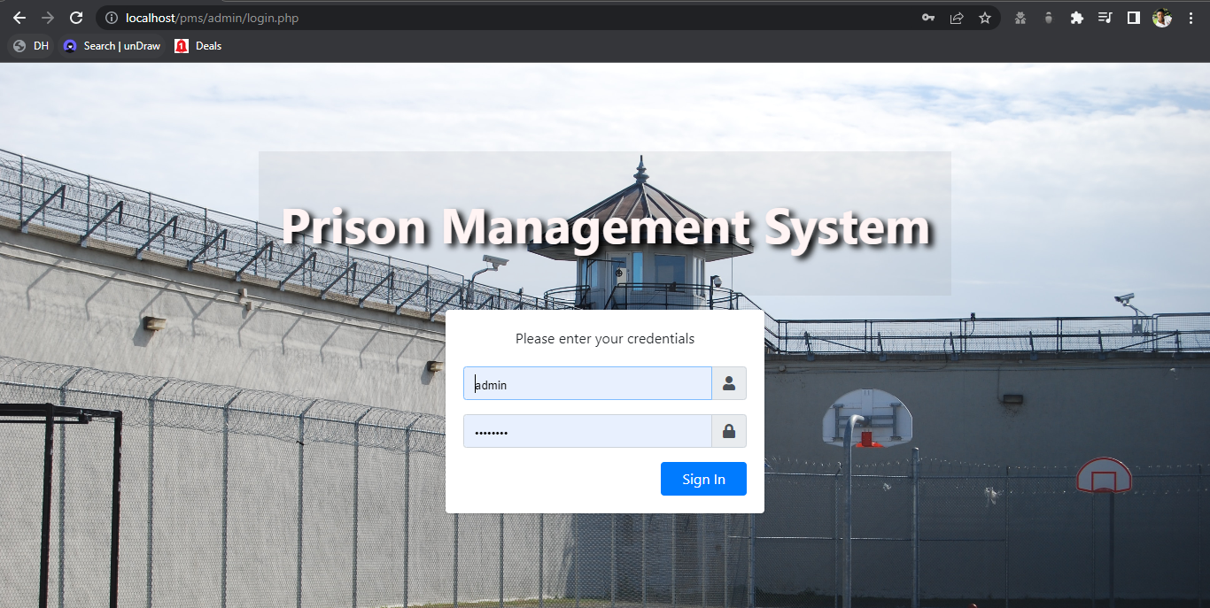

**Fig 4.6.1: Homepage**

**4.6.2 Administrator Dashboard**

This is the admin dashboard.

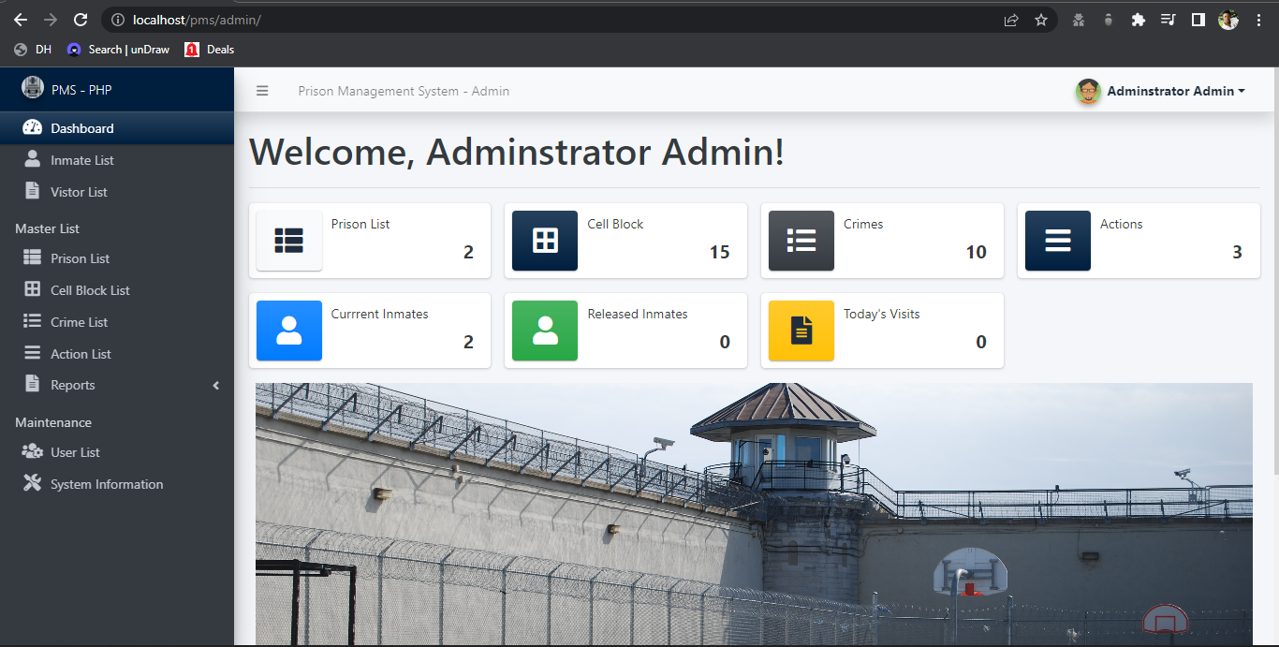

Fig 4.6.2: Admin Dashboard

**4.6.3 Inmate List**

This is the list of all inmate in the prison where changes can be made to inmate information.

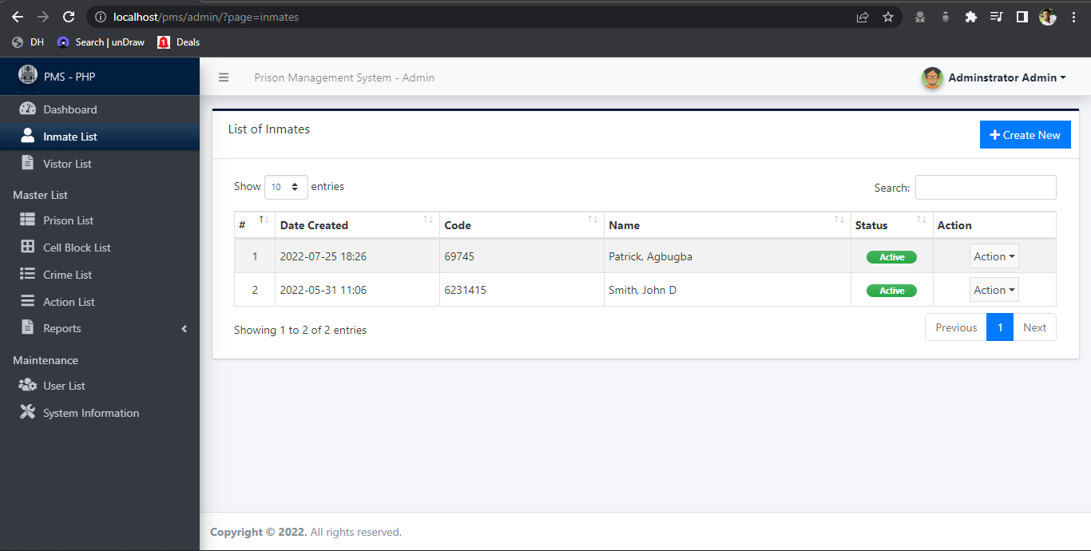

4.6.3 Inmate List Page

**4.6.4 Visitors List**

This page contains all the visitors list.

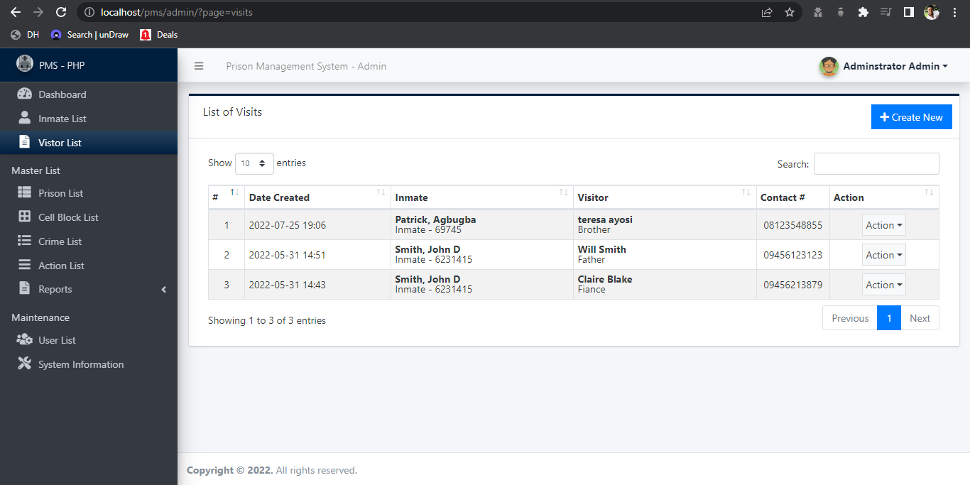

4.6.4 Visitors List

**4.6.5 Inmate Report**

This is part of the admin page where admin can view the records of inmates.

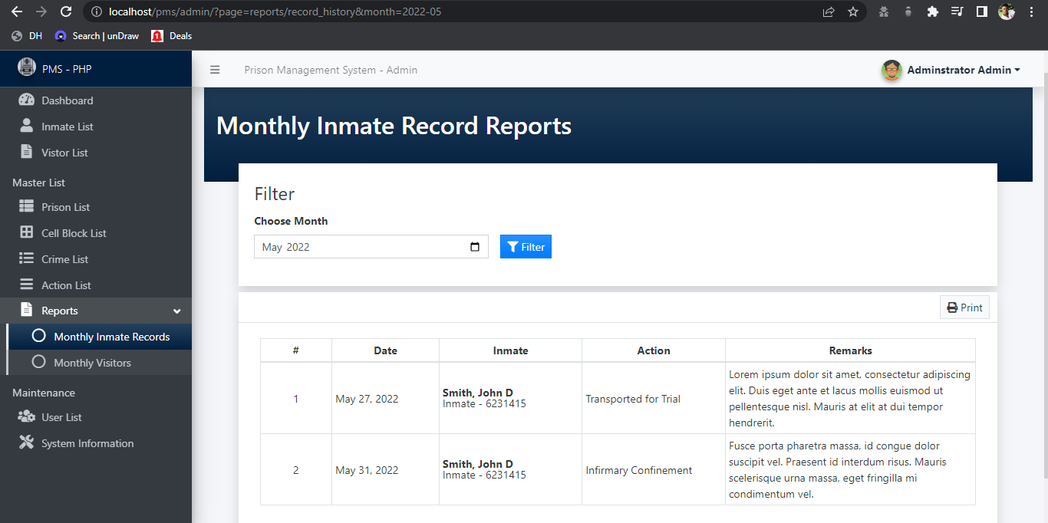

4.6.5 Inmate Report

**4.6.6 Add Crime**

This is a page for adding crime so that it can be used dynamically when adding inmate.

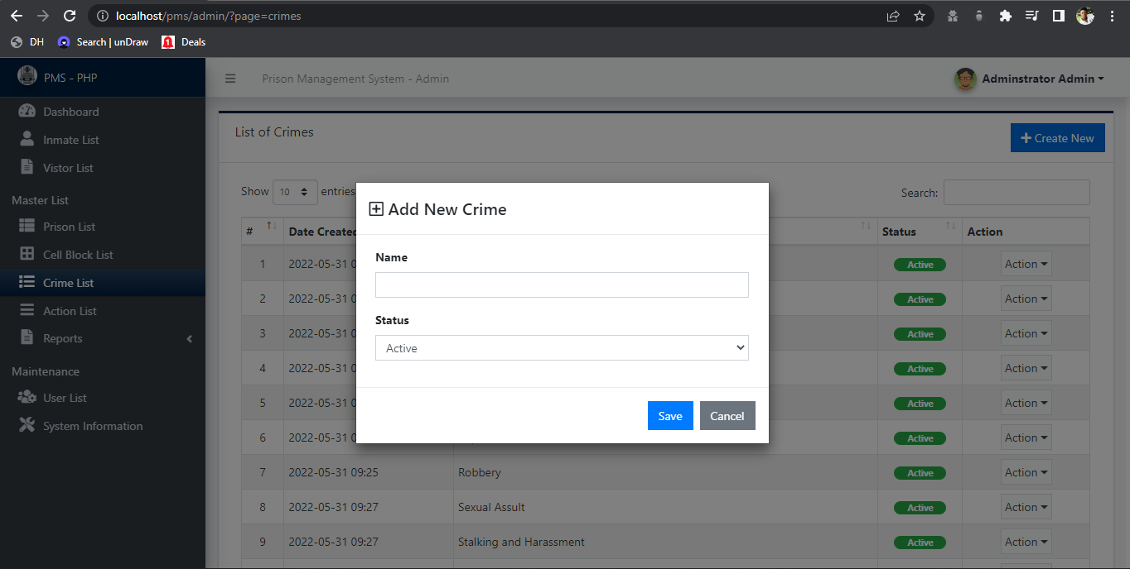

4.6.6 Add Crime

**CHAPTER FIVE**

**SUMMARY, CONCLUSION AND RECOMMENDATION**

**5.1 Summary**

In this project, we developed an automated prison management system that facilitates some various activities that happens in prison. This project was design to solve a problem that exist in the manual system of prison, this project also serves as a replacement for the outdated manual system. The project was a success and the set-out goals of the project was achieved.

**5.2 Conclusion**

The project was conducted successfully and the purposed of the new system was also achieved. The new system is an improvement compared with to the existing system. The new system is user friendly and it has new features that will be helpful to the organization.

**5.3 Recommendation**

To enhance the efficiency of the system, in the following we have listed some recommendations and future works.

Where possible, ensure that pre-trial detainees are well documented and individuals detained in facilities other than general prisons should be captured as well.

**REFERENCE**

Abecker, Borrington, D. (2018). Human Resource Management seventh edition. London:

Pearson Education Limited.

Aderind, A. & Stepheny, P. (2018). Human Resource Management fifth edition. Australia:

Australian Press.

Alan, P. (2017). Human Resource Management in a Business Context. London: Pearson

Publication Limited.

Bratton, J. & Gold P. (2019). Human Resource Management: Theory and Practice. London:

Palgrave Macmillan.

Cenzo & Robbins. (2017). Human Resource Management: Approach and Practice. Alaske:

LaGreen.

Hamlet, J. (2017). Cultivating Alliances with Customers. International Journal of

Organizational Management, New York. Vol. 7. Issue 3, pp. 255-287.

HRM Guide October. (2018). Human Resource Management fifth edition. Canada: John

Wiley & Sons Inc.

Rosenberg, I.J. (2016). A Simple Approach to Service Delivery. Journal of Customer

Retention, Toronto. Vol. 1, pp. 45-51.

Srinivas (2014). Management Information System: An article on mis. California: Wedge

Publishers.

Torrington, D. (2014). Human Resource Management sixth edition. London: Pearson

Education Limited.

Ullman & Wisdom (2017). Computerization for Change. Palo Alto, California: Mayfield

Publishing Company.